Pipelines, Netbacks and Trade: A Case Study of the Oil Sands

Andrew Leach

March 2019

### Introduction

The rise of light tight oil since 2008 has fundamentally altered global crude oil markets: it has added more than 5 million barrels per day of production at relatively low costs, it has caused a prolonged and un-expected depression in oil prices, and has changed the geopolitics of crude oil markets. In North America, the change has been even more pronounced. Regions which had historically been short oil, like the US Midwest, became over-supplied and started moving oil out to other US markets. The US Gulf Coast, long solely an oil importer became an exporter of crude oil, at least the lighter and medium grades thereof, while continuing to import heavier crudes. We've seen what used to be premium benchmark prices such as West Texas Intermediate (WTI) invert to trade at significant discounts to global crudes such as Brent, and a host of other pricing relationships have followed. This new resource play has created what is, in many ways, a perfect storm for Alberta’s oil sands.

Stuck at the northern end of the North American pipeline network is Alberta. For decades, Alberta benefitted from easy access to northern US markets willing to pay a premium for oil in general, and saw many refineries in those regions refit to process the heavier crude which began to flow from Alberta's newer, in situ oil sands projects. Now, those refineries have benefitted from a market over-supplied with heavy crude and Alberta, isolated from other markets, has seen its products face large differentials and its economy face an uncertain future. While much of this challenge in Alberta has been passed off as a lack of market access or, more simply, a lack of pipelines, this chapter will take that analysis one step deeper and argue that Alberta has also seen its market eroded by the change in flow in North American oil markets which has set Alberta's crude further away from key markets and which makes a return to the good times in Alberta something which will not be achieved simply with the construction of pipelines. That’s not to say, of course, that pipelines don’t matter – they do. They just won’t usher in a return to the boom times of the past decade.

This chapter proceeds as follows. First, we characterize the changes in production in both Canada and the United States, with a particular focus on the Canadian oil sands and the US light, tight (or shale) oil production. We then show and discuss how these changes in production, along with regulatory changes, have led to changes in crude movements into and out of Canada and the United States. Next, we examine how infrastructure constraints, combined with these changes in flows, have altered the value of Canadian crude oils and, in particular, the value of oil sands bitumen. Finally, we look forward to the potential roles of pipeline construction and re-alignment to increase the value derived from Canadian crude oil production: the value of infrastructure to the Canadian oil sands.

### North American Oil Production Growth

Beginning around 2008, North American oil and gas companies began exploiting the combined innovations of horizontal drilling and multi-stage hydraulic fracturing to allow the extraction of long-known hydrocarbon deposits. The gas deposits in the northeast and Appalachian regions and oil in North Dakota’s Bakken and the Permian and Eagle Ford Regions in Texas have boomed and continue to drive US production.

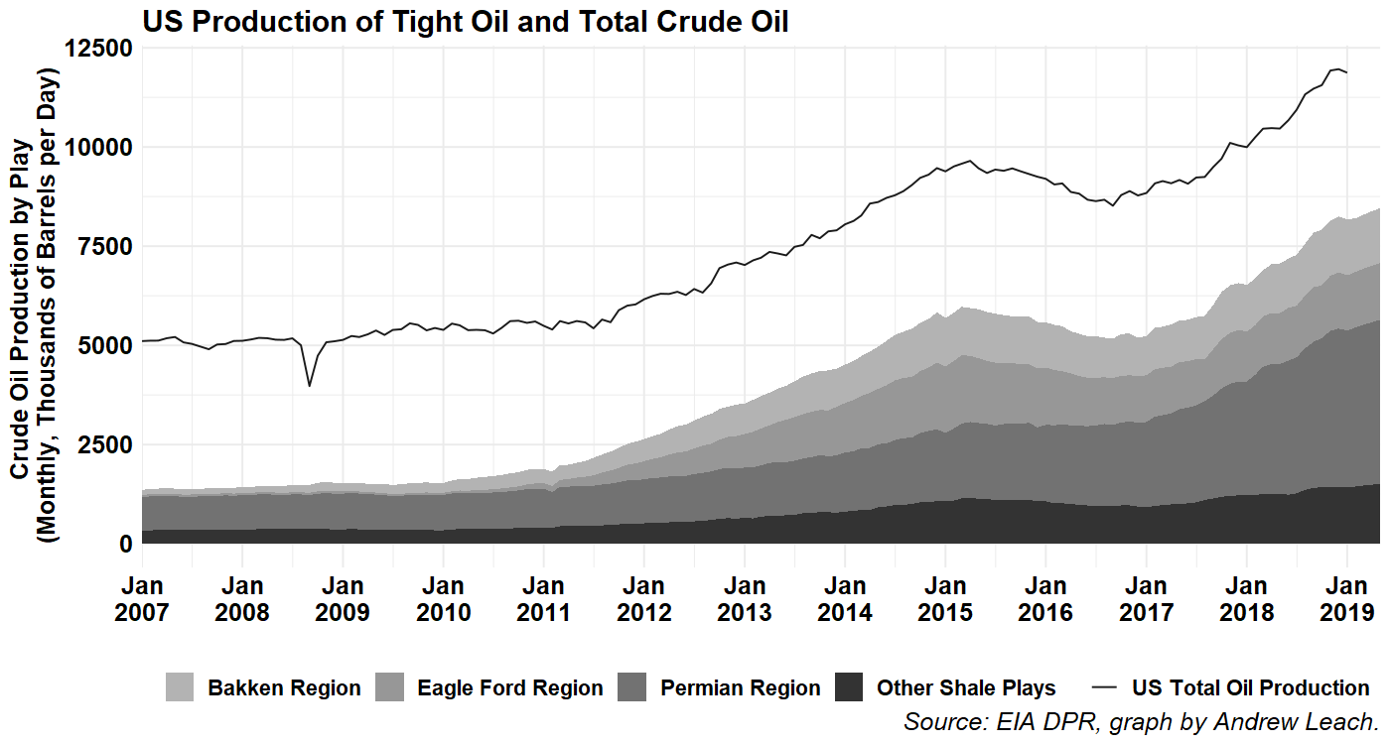

Figure 1: US total oil production and oil production from key light tight or shale plays.

As shown in Figure 1, US total oil production has increased to approximately 12 million barrels per day, with the total production from light tight oil having grown by over 5 million barrels per day since 2008.

Canadian production has also been growing over this timeframe, fueled mostly by the oil sands boom in Alberta, but also continued production in Saskatchewan, BC, and Manitoba in the West and Newfoundland and Nova Scotia in the East as shown in Figure 2.

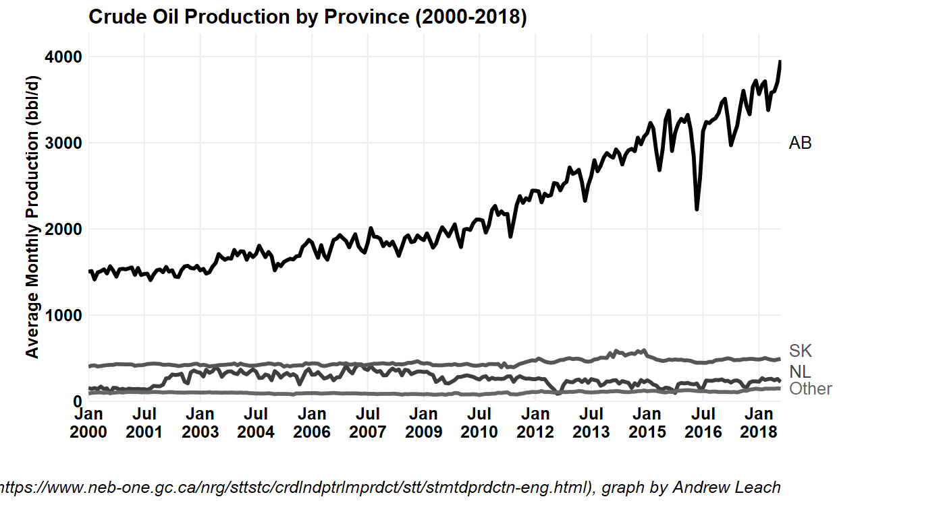

Figure 2: Canadian oil production by province

We don’t discuss Mexican production much in this chapter since, for our purposes, their lack of pipeline connection to the US implies that they are treated like any other global crude. However, Mexican production has been a bit of a countervailing force in North America. As of the end of 2018, Mexican crude oil production had dropped to 1.7 million barrels per day from a peak of 3.5 million barrels per day in 2003. (EIA IEO Data, 2019)

### North American Refining Capacity

### 

US and Canadian refineries have evolved to serve demand centres for the most part, with the exception of the massive refining complex on the US Gulf Coast. Historically, Canadian crude exports served the major demand center in the US mid-continent, from the western end of Lake Superior south and east through the Great Lakes region. More recently, with the decline in Mexican and Venezuelan production and the rise in oil sands production, we’ve seen more Canadian crude making its way to the Gulf Coast.

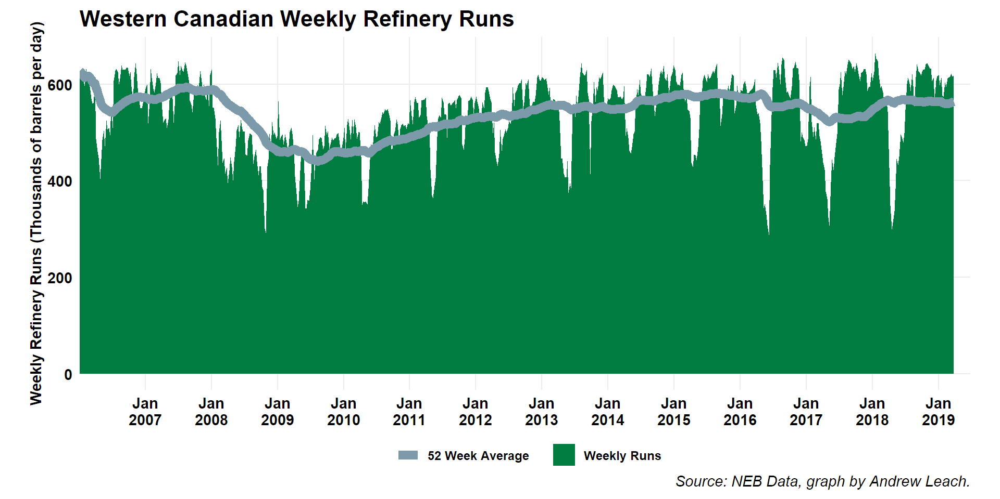

In Western Canada, not including refineries west of the Rockies, refinery runs should be expected to average about 90,000 cubic meters (560,000 barrels) per day. NEB data for 2018-2019 shows an average run rate of approximately that level, but their reported data do not include the Northwest Redwater Refinery but do include the Parkland Refinery in Burnaby. Once Northwest Redwater is operating at full capacity, we should expect approximately 95,000 cubic meters (600,000 barrels) per day of crude supply processed at refineries in the areas of Western Canada East of the Rockies.

Crude supply into this region will exceed refinery demand, leading to significant call on exports. The Canadian Association of Petroleum Producers (CAPP) (2018) estimates 2019 supply to be 762,000 cubic meters (4.8 million barrels) per day, leaving a net demand for export capacity of approximately 667,000 cubic meters (4.2 million barrels) per day in 2019. With no significant expansion of refinery capacity planned, and expected production expansion of 222,000 cubic meters (1.4 million barrels) per day by 2035 per CAPP (2018), the call on export pipelines is expected to increase.

The capacity of existing pipelines is insufficient to meet this export demand. Currently, the capacity of the existing pipeline network out of Western Canada is approximately 4 million barrels per day (NEB, 2018) with variations in any given month. There are currently 3 projects which will, if completed, add capacity to this network. Improvements to the Enbridge mainline including the Line 3 replacement project, as well as the expansion of the Line 67/Alberta Clipper pipeline, along with other system enhancements could add as much as 670,000 barrels per day of capacity to the US Midwest (Enbridge, 2019). TransCanada’s Keystone XL project would, on its own, add a further 830,000 barrels per day. And the TransMountain pipeline expansion project would add approximately 600,000 barrels per day. Combined, these projects would add over 2 million barrels per day, more than sufficient to accommodate planned production expansions for most of the next two decades, as shown in the Figure below.

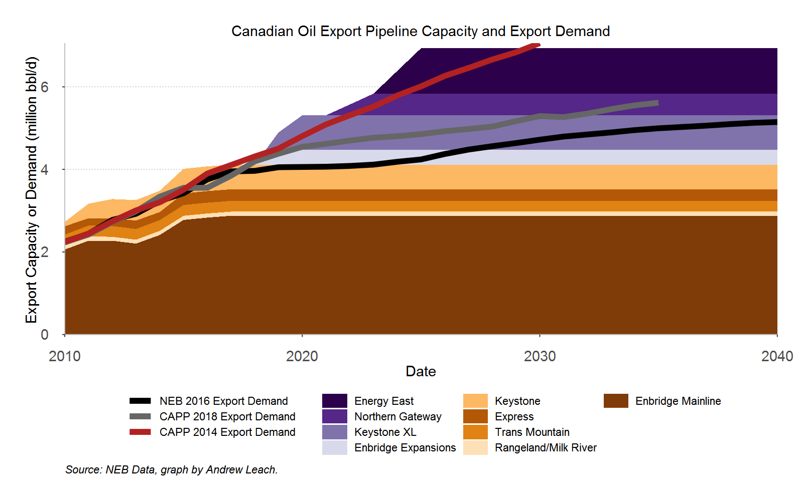

Two other previously-proposed pipeline projects, the 1.1 million barrel per day Energy East project linking Hardisty, Alberta and the Canadian east coast port of Saint John, New Brunswick and the 525,000 barrel per day Northern Gateway project from Edmonton, Alberta to the west coast of Canada at Kitimat, BC are also shown on this graphic, as is an older export demand forecast from CAPP (2014). These are included to show the degree to which demand for export capacity has decreased with the decline in global oil prices since 2014, and the degree to which these projects have become superfluous to expected offtake demand.

### North American Oil and Product Demand

The United States continues to drive demand for oil and petroleum products in North America. In 2018, US product supplied (a proxy for demand) for crude oil and petroleum products averaged 20.4 million barrels per day. With demand up more than 1 million barrels per day since 2015, US demand threatens to set new historic highs in 2019 or 2020. US product supplied reached its peak in 2005, with 21.6 million barrels per day of demand. In the US, crude oil inputs to US refineries have increased since 2009 lows by over 2.6 million barrels per day. (EIA 298402)

Canadian domestic sales of petroleum products are seeing a similar resurgence with 2018 average sales being the highest 12 month sales ever seen in Canada for total products surpassing previous peaks in the 2011-2015 period. Canadian refinery runs, on the other hand, have been declining from highs reached in the mid-2000s, and Canadian crude deliveries to Canadian refineries are down from 1.9 million barrels per day in 2004 to 1.7 million barrels per day in 2018. (Statistics Canada, 2019a and 2019b – see energyplotsnew.R)

While US refinery inputs have increased, they have not kept pace with total crude production. This has led to an increase in US exports of crude oil to over 3 million barrels per day and a decrease in net imports of crude oil to less than 4 million barrels per day by early 2019. (EIA 314539) Similarly, the US increase in refined product consumption has not kept pace with US refined product production, and so net exports of petroleum products have also increased to over 2.5 million barrels per day. (EIA 314539)

Canada has seen much the same evolution in trade. Our crude oil exports have increased to an average of 3.7 million barrels per day in 2018, with net exports averaging 2.9 million barrels per day. On the products side, we have 300,000 barrels per day of imports and approximately 450,000 barrels per day of exports.

On the whole, from a crude oil markets point of view, this leaves North America roughly in balance for crude oil, with slight total net imports of 1 million barrels per day between Canada and the US. With Mexico included, the entire continent of North America is in crude oil balance and petroleum product surplus – a drastic change from what would have been foreseen less than a decade ago.

While the total market dynamics are important for Canada, what matters more is where US crude production has occurred and how that has changed what were, for a time, our key markets.

### Changes in Crude Movements

We tend to frame our trade as occurring between countries – Canada and the US – however, for crude oil, it’s best to think of trade as occurring between distinct markets and then think of transportation infrastructure as the means to connect those markets. In Canada, most of our trade has historically gone to the US Midwest for both geographic and economic reasons. Changes in crude flows in and out of the Midwest have drastically changed the value of our crude oil.

Most of what follows in this section relies on differences in transportation costs and regional arbitrage. If transportation were both costless and not capacity constrained, then prices in different markets would tend to the same values. If transportation were also instantaneous, then there would be no economic driver for price differences between markets. As it is, transportation is neither free from capacity constraints nor costless and so we do see long-term discrepancies between prices in one region and another. There is also not a single shipping price, but rather a continuum of costs depending on the method chosen: long-term pipeline contracts tend to be cheapest, while truck transport tends to be the most expensive, with spot service pipeline contracts, rail shipments, and barges filling in the intervening values. Finally, shipping capacities may not be symmetric, in the sense that pipeline capacity to flow from A to B is not, in a short timeframe, equivalent to capacity to flow from B to A. Pipelines can be reversed, but this takes time and regulatory approvals. Rail, truck, and barge capacity is more nimble, but loading and unloading infrastructure may not be perfectly reversible in very short time periods.

So, let’s start with crude movements within the US. Historically, the dominant flows into the US market for crude oil were imports into the east, south and west, with flows from the Gulf Coast north into PADD 2. As shown in Figure 3, all US regions have been and continue to be dependent in crude imports, with increasing imports from Canada in the Midwest and decreasing imports into the east and gulf coasts, with stable imports into the West Coast. The movements between regions shown in Figure 3 also tell an important story of domestic production. Beginning in 2008 or so, production in PADDs 2 and 3 begins to account for an important share of crude supply. In PADD 2, we also see rapidly decreasing movements from PADD 3, while we also see increasing supply into PADD 3 from PADD 2: the region into which most Canadian pipelines flow quickly became oversupplied by mid-2010 and shipments into the Gulf Coast and, to a lesser degree, by rail to the east and west coasts became a safety valve.

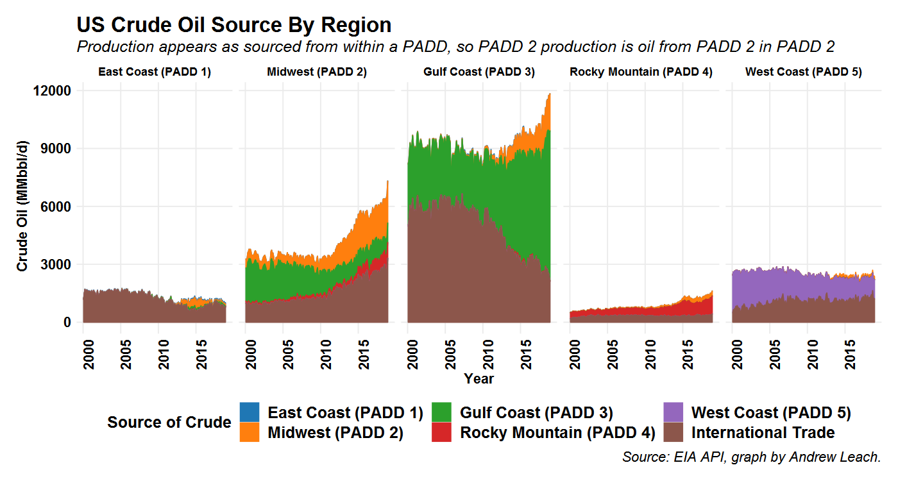

Figure 3 US Movements of Crude Oil Between PADD districts by pipeline, tanker and barge. Source: EIA (2019)

The second half of the story comes from looking at where does US regions send its crude oil. In Figure 4, we see the rising movements out of the US Midwest and out of the US Gulf Coast. With the reversal of the Line 9 pipeline in Ontario to allow delivery from Sarnia to Montreal, along with projects such as the Flanagan South and Seaway projects on the Enbridge system and the Marketlink project on TransCanada’s system, crude can and now does flow from the Midwest both east and south. From the Gulf Coast, we see what used to be a large, historic flow north into the Midwest mostly reversed. This was initially offset by declining imports of crude oil, but more recently has been offset by increasing exports of light oil while the Gulf continues to import some heavier crudes to supply its refineries. Some of those Gulf Coast exports are imported to eastern Canada, which now receives over half of its crude imports from US suppliers. (National Energy Board)

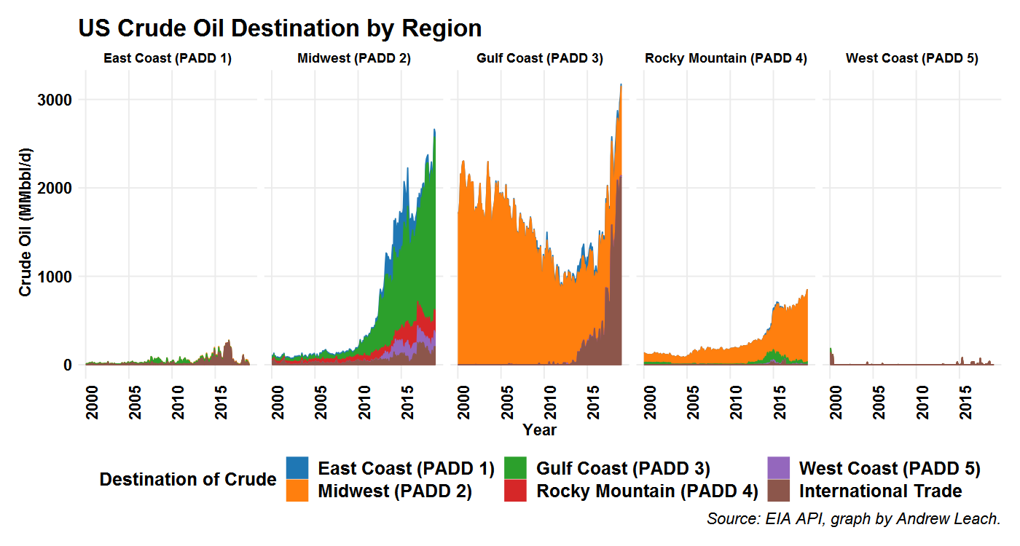

Figure 4 US Crude oil destination by region. Source: EIA (2019)

The impact of these changes in US market flows is evident in Canadian crude movements with rising exports with a Gulf Coast destination. We still ship about 2 million barrels per day to the US Midwest, but according to NEB data shown in Figure 5 we now ship approximately 1 million barrels per day to the US Gulf Coast, a figure which does not account for barrels shipped initially to the US and then blended and shipped onward to the Gulf.

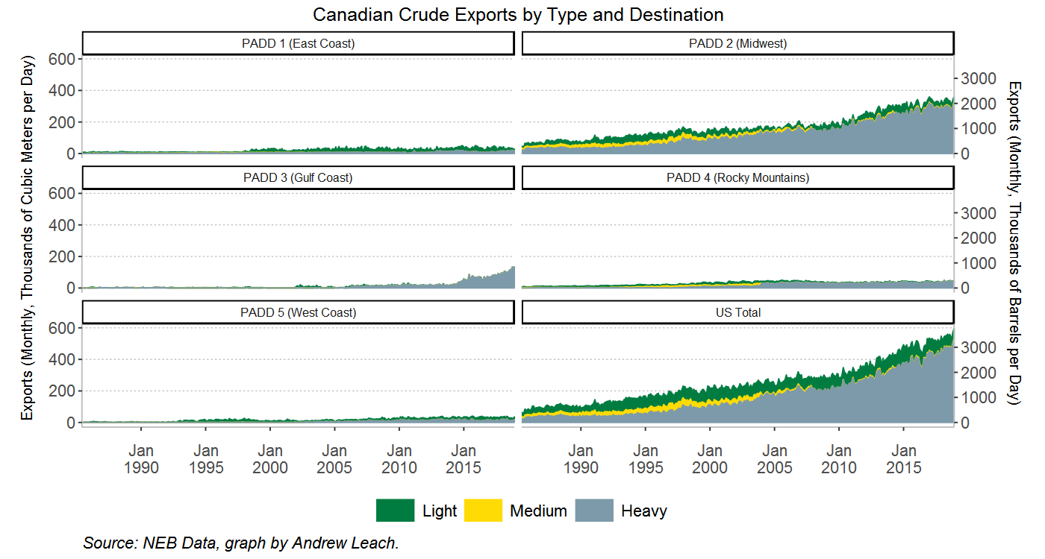

Figure 5 Canadian Crude Exports by Destination. Data via National Energy Board (2019)

### Pipeline Utilization

There is no single data point that one can cite to justify that our existing pipeline infrastructure is *full*, although we can point to many market indicators. The first and most obvious is utilization. In the last quarter of 2018, pipeline utilization among the three major export pipeline systems (TransCanada Keystone, Enbridge Mainline, and Transmountain) was 98%. (NEB, 2019). We can also ask whether pipelines are oversubscribed, and they are. In almost every month since mid-2016, each of the three main pipelines has seen excess demand for their common carrier capacity. This is an imperfect metric, since there is significant evidence of over-nomination of barrels, or shippers requesting shipping service for more barrels than they intend to ship in order to get a larger pro-rated share of the scarce, available capacity. This has, at times, reached near-comedic proportions. For example, the NEB (2019) found that, “in December 2018, more than 13 million barrels per day of oil were nominated for shipment on pipelines exporting oil from western Canada,” which is more than double the total supply theoretically available for export that month. Finally, of course, we can look at spot pricing differentials. If pipeline capacity were available, no matter who holds the contract for that capacity, it should almost always be worth it to ship crude if crude is available in the domestic market at a substantial discount. Through most of late 2018, that was certainly the case, with market pricing differentials to comparable grades of crude oil many multiples larger than pipeline tolls to compete in those markets.

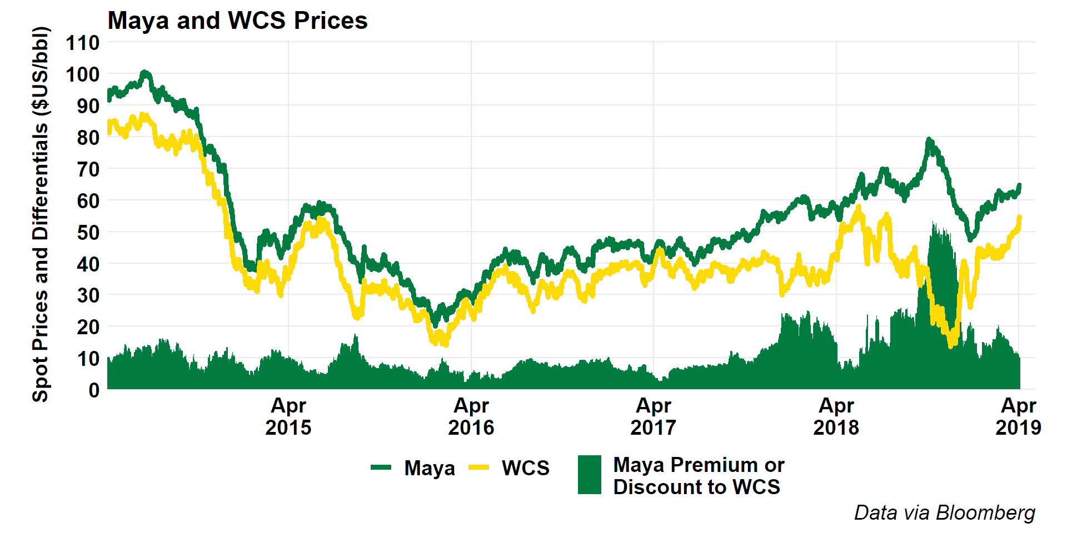

For example, consider the data above which show prices for Western Canada select, a diluted bitumen and heavy oil blend priced for delivery at Hardisty, Alberta and the free-on-board price for Maya crude on the US gulf coast. When we consider that the uncommitted, joint tariff for delivery from Hardisty, Alberta to the US Gulf Coast on the Keystone system is $US 10/bbl and US$8.87 per barrel on the Enbridge system, differentials between the two markets of more than $10-15 per barrel must reflect unavailable pipeline capacity and storage shortages in Alberta, which was also the case in late 2017 and much of 2018.

The interaction between apportionment rules, limited available pipeline capacity, and lack of available storage is where we really start to see the impact of constrained pipeline capacity on resource value. The NEB (2019) does an excellent job of explaining this dynamic:

When shippers over-nominate to pipelines, apportionment is exacerbated. Contracts in place between producers and shippers are structured such that a shipper is able to “push back” apportioned barrels to the producer. As apportionment levels increase, more barrels can be pushed back to producers. This sudden, artificial increase to the oil supply in the local market can cause western Canadian crude prices to become severely depressed, particularly when producers lack access to adequate storage. Consequently, producers receive materially lower prices for their crude oil. NEB (2019)

The NEB also explains that, of course, the over-nomination of crude oil to pipelines by certain shippers leaves them with excess capacity which they are then able to fill with distressed or stranded barrels they purchase at hefty discounts from contracted producers with no other options.

### Crude by Rail

One option which does exist in a pipeline-constrained market is to ship crude oil by rail. Crude by rail is generally more expensive than shipping crude by pipeline, with ARC Energy (2019) estimating $16 to $20 per barrel costs to move Western Canada Select barrels from Hardisty to the Gulf Coast. As a rule, if uncommitted pipeline shipments are available at $8.50 to $10, that will be a preferable option and rail will be relegated to use where a niche market exists or where there is an advantage to shipping crude rapidly, as rail has shorter cycle times. As shown in Figure 6, Canadian crude by rail shipments have been at or close to record highs in late 2018 and early 2019, but have been rising steadily since pipeline apportionment became more expected in mid-2016. Many shippers have built or contracted with rail loading terminals to be able to access rail service in anticipation of the coming pipeline constraint. While rail does allow quantities of crude to leave Alberta, it is only viable at higher volumes if producers are forced through other constraints to sell their crude at a significant discount to prices in destination markets.

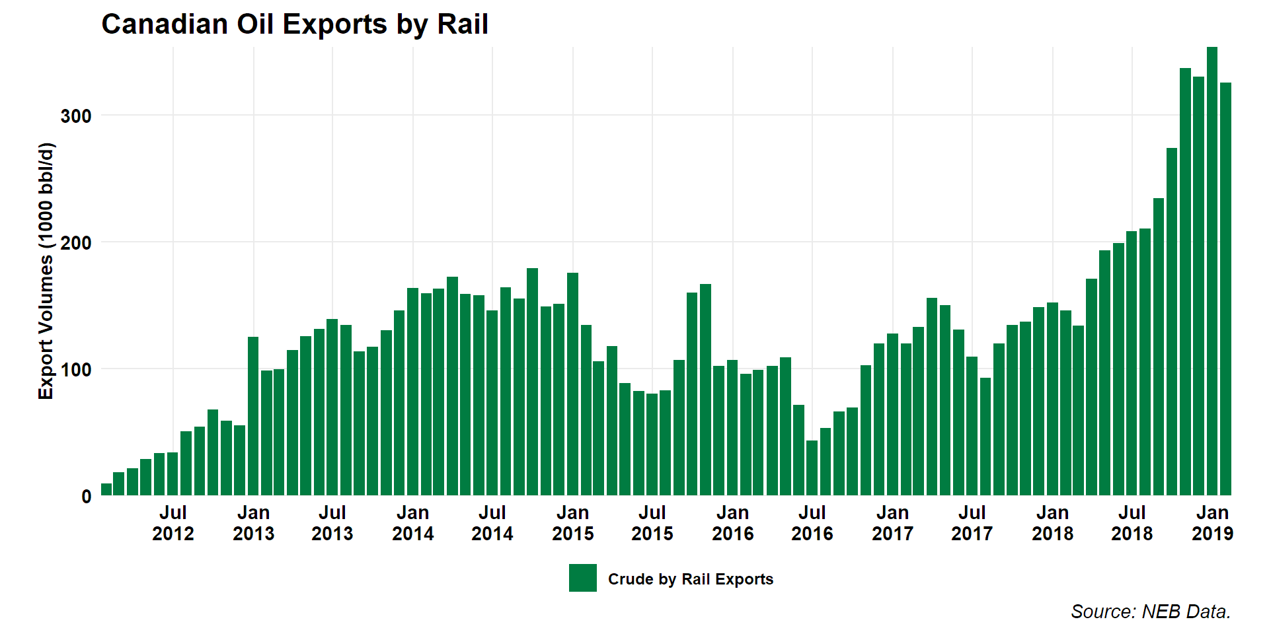

Figure 6 Canadian Crude By Rail Exports

### The Role of Diluent

We don’t talk very much about diluent when we talk about oil sands and infrastructure, but the ability to deliver diluent is a very important part of the supply chain.

Currently, two pipelines provide import capacity for condensate, Enbridge Southern Lights (180 000 barrels per day) and Kinder Morgan Cochin (95 000 barrels per day). In total, Canadian imports of natural gasoline or pentanes plus used as diluent averaged 180 000 barrels per day in 2018. This, combined with total Canadian natural gas condensate and pentanes plus production of 365 000 barrels per day, provides an important input to shipping oil sands bitumen. (StatsCan 25-10-0063-01)

An oil sands barrel shipped as diluted bitumen will contain approximately 30% diluent. This means that, for the 1.8 million barrels per day of non-upgraded bitumen that is expected to be produced in Alberta, approximately 750,000 barrels per day of diluent would be required to allow the blended product to meet pipeline specifications. Some of these shipments within Alberta would see the diluent recovered, such that diluent exports from the provide will be a bit smaller than the total Alberta Energy Regulator (2018) forecast for diluent demand of 750,000 barrels per day in 2019. Nonetheless, when you account for both condensate imports and diluted bitumen exports, we use over 1 million barrels per day of pipeline capacity moving diluent to and from Alberta every day.

Diluent also matters in pricing, as diluent feeds are more valuable than bitumen or heavy oil feeds. For a typical heavy crude oil blend of bitumen and diluent, the diluent could be as much as 50% of the cost of goods sold if we value both the bitumen and the diluent at market prices.

### Canadian Oil Netbacks and the Value of Pipeline Capacity

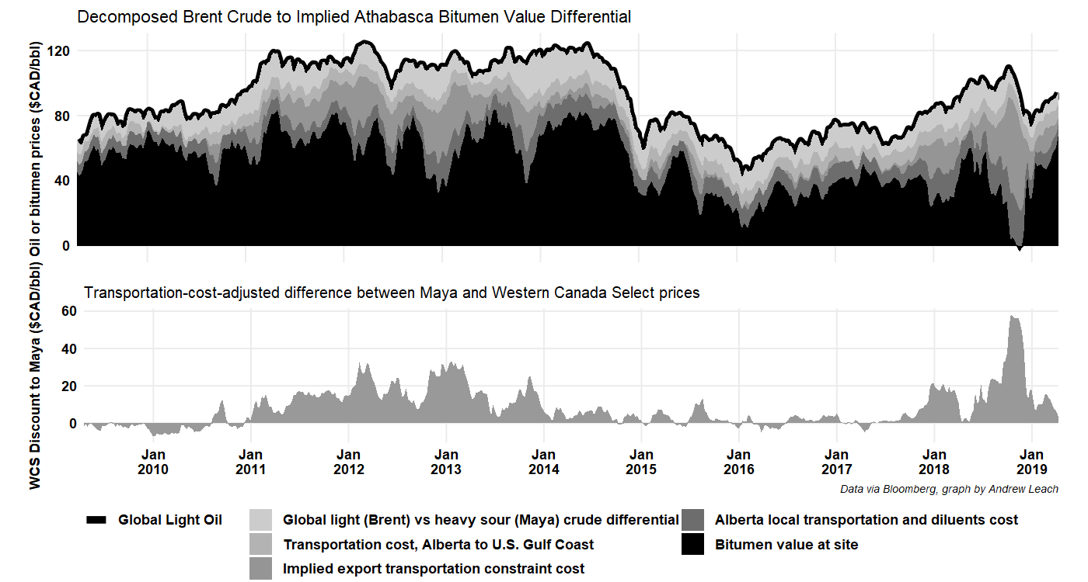

Source: EIA AEO 2018 Lower 48 onshore tight oil development will drive US crude oil production, accounting for 65% of domestic production during the forecast period. The Permian and Bakken/Niobrara basins will lead production. Growth in the Gulf Coast region increases through 2025 before flattening out as drilling in the Eagle Ford region becomes less productive: Oil production (mb/d) 2017 2030 Growth Permian 2.5 4.0 3.7% Bakken/Niobrara 1.7 2.4 2.5% Eagle Ford 1.6 1.9 1.6% Source: EIA AEO 2018

What about US domestic consumption for crude? The same AEO report expects consumption to peak and begin to decline, resulting in the US becoming a net exporter by 2022. Global supply and demand The International Energy Agency’s (IEA) New Policies scenario accounts for policies and measures that governments have already put in place as well as the likely effects of announced policies and expressed plans. Two key assumptions that impact the IEA’s World Energy Outlook are the changes underway in China’s economy and energy policy which will largely affect demand, and the rapid growth of tight oil in the US. In the long-term, production from the Middle East and OPEC is expected to slightly grow with the majority of production coming from Iraq and Saudi Arabia. In the medium term, output is expected to decline in nearly all OPEC member countries outside of the Middle East with the exception of Libya who have managed to increase production despite the ongoing civil unrest threatening its oil infrastructure. The economic crisis and political instability in Venezuela is expected to persist, therefore the IEA predicts that they will unlikely increase production in the forecast period. The majority of Latin American crude oil production growth will come from Brazil. Despite new production from projects in east Siberia and the Arctic, total Russian oil production is projected to decline through the forecast period as growth slows in the mature production regions of western Siberia and Volga-Urals. Oil production (mb/d) 2017 2030 Growth Middle East 32.0 35.4 0.8% Latin America 10.0 12.2 1.5% Russia 11.3 9.7 -1.2% Source: IEA WEO 2017 Total world oil production is expected to grow to nearly 100 mb/d by 2030 - 42% of this coming from OPEC:

Source: IEA WEO 2017 Canada’s supply and demand balance Western Canadian crude oil supply has been increasing steadily for the past number of years, driven primarily by oil sands growth. From 2010 to 2016, total supply increased from approximately 2.5 million b/d to 3.9 million b/d. According to many forecasters, Canadian production is expected to continuing growing, albeit at a slower pace than previously thought. The outlook for 2030 for total Western Canadian supply from CAPP shows production reaching over 5 million barrels per day.

Canada’s total refining capacity is 1.9 million barrels per day (TK), with Western Canadian crude accessing primarily the Western refineries due to the setup of the pipeline network and Eastern refineries configured for light crude.  
From the balance, Canada is primarily an exporter of crude and historically has moved crude on pipelines and small amounts on rail. As with other producing regions, at many times over the past decade, supply has grown faster than the infrastructure needed to transport it out of the region and with all the challenges around building new infrastructure this is expected to continue to be the case. Pipelines and flows Today, Western Canada has over 4 million barrels per day of export pipeline nameplate capacity, but operational capacity is closer to 3.3 million barrels per day (CAPP 2017). This lower operational capacity means that all pipelines are running at capacity, and many are on apportionment.  
Almost all of Canadian crude exports today go to the US, primarily to the US Midwest market, with a smaller proportion reaching the US Gulf Coast.

However, as Canadian crude production continues to grow, additional barrels will need to travel further to find a market. The US Gulf Coast has a significant amount of heavy refining capacity, making it a natural market for Canadian heavy crude. What are the challenges to get more crude to the US Gulf Coast? First, Canadian barrels will compete with heavy barrels from other regions, like Mexican Maya and Venezuelan barrels. Second, while the current pipeline network can reach the Gulf Coast, ie Seaway or TransCanada Gulf Coast, light and heavy barrels today both travel on these lines, and it depends on who hold the contracted capacity. Lastly, transportation costs will come into play - it is more expensive to transport a heavy barrel of crude than a light barrel and Canadian barrels are competing with waterborne barrels from other locations - which generally have lower transportation costs.  
In addition, as production grows and given the global competition of heavy barrels, it is beneficial to open markets for Canadian barrels outside of the US. There are other parts of the world with heavy refining capacity, for example, parts of Asia and Mediterranean Europe.  
Given the need for additional export capacity, there are three projects that are proposed at this time: the Trans Mountain Expansion, TransCanada’s Keystone XL and Enbrige’s Line 3 replacement.  
Cost and pricing At several times over the past decade, the total number of crude barrels available for export out of Western Canada has exceeded the available pipeline capacity and prices have weakened significantly as a result.  
This is best shown in the difference between Western Canadian Select (WCS) and West Texas Intermediate (WTI). The WCS-WTI differential, at a most basic calculation, represents the quality and locational differential between a light, sweet barrel located in the US Midwest (WTI) and a diluted bitumen (heavy, sour) barrel produced in Alberta. If all of the fundamentals of supply and demand are in balance, the difference between those two would be less than $10/bbl, but it is rare that all factors are in balance. In the cases when there has been insufficient takeaway capacity, the price is set by the next available transport option, like rail -which is more expensive, and if that is unavailable, then it could represent the cost of putting the barrels into storage, or finally the cost of shutting production down. As has been mentioned, there have been several times over the past decade when a lack of pipeline capacity has resulted in a much wider differential between WTI and WCS; in 2012, 2013 and in early 2018, the differential was wider than $25/bbl. For example, in early 2018, world prices for crudes were in the $60/bbl range and WCS was pricing around $36/bbl.

Netbacks

Historically, the majority of Canadian flows have moved to the US Midwest due to higher netbacks. For example, WTI 65 - quality discount $3- $5 tcost on Enbridge, Canadian producer achieved 57.  
The cost of transport for a heavy barrel to the Gulf is about $10(calcEnbridge),soMayatodayispricingat63.16-10=53.16.Thecurrenttransmountaincostis5$ but you get an Asian based price for it. Even assuming shipping cost of 2, heavy price at 70(?)-5-2 =63

### The Case for New Pipelines

### Upgrading, Refining, and the Case for Pipelines